**Instructions for annotating “linked” detections**

Aaron Thode

August 2014

This document explains how to load and edit annotations for linked files in Ulysses, formerly known as “All File Specgram Viewer”. Acoustic files from two recorders are considered “linked” if the acoustic recorders were deployed close enough together such that a single bioacoustic “event” (e.g. a whale call) can be detected on both instruments. The linking features in Ulysses allow one to link annotations describing the same event between annotation files, and thus annotate a single event simultaneously. As of now, only files that end with the ‘GSI’ extension have this feature. GSI stands for “Greeneridge Sciences Incorporated,” and are files from a particular recorder known as a DASAR**ref**. DASARs are deployed in groups of seven along triangular grids known as “Sites”. The southernmost recorder is labeled “A,” and the northernmost is “G”. DASARs are deployed 7 km apart. The files used here to demonstrate are in Jonah.ucsd.edu: Data/Shell2010_GSI_Data/S510D0/. We will be be working with the August 31 (0831) files. If asked for a calibration keyword, keep “DASARC” and hit return.

Linking annotation controls and link display

If a GSI file is loaded into Ulysses, the following new controls—“link up” and “link down” appear:

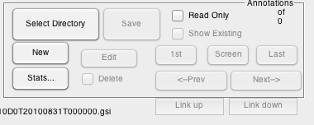

To begin, load a GSI file, select “update,” and then load an annotation file by hitting “Select Directory”. Eligible annotation files will have the keyword “East,” “West,” or “Center” in them. Hit “Screen” to move to the nearest annotation. In the following examples, I will be starting with S510D0T20100831T000000.gsi, or DASAR D from Site 5 during 8/31/2010. One GSI file covers one day.

Figure 1 shows how a linked annotation is displayed, if one hits the “Screen” button after loading this file. In addition to the regular “Annotation detail” window, a new window appears: a map of the location of a call. Each red triangle represents an acoustic recorder that is linked to the current annotation. Each blue line represents a bearing to the call, as detected by a particular recorder. A thick blue line indicates the bearing of the call currently visible on the screen. As is the case for a regular annotation, the current annotation should be highlighted by a pink box, as can be seen in Fig.1 .

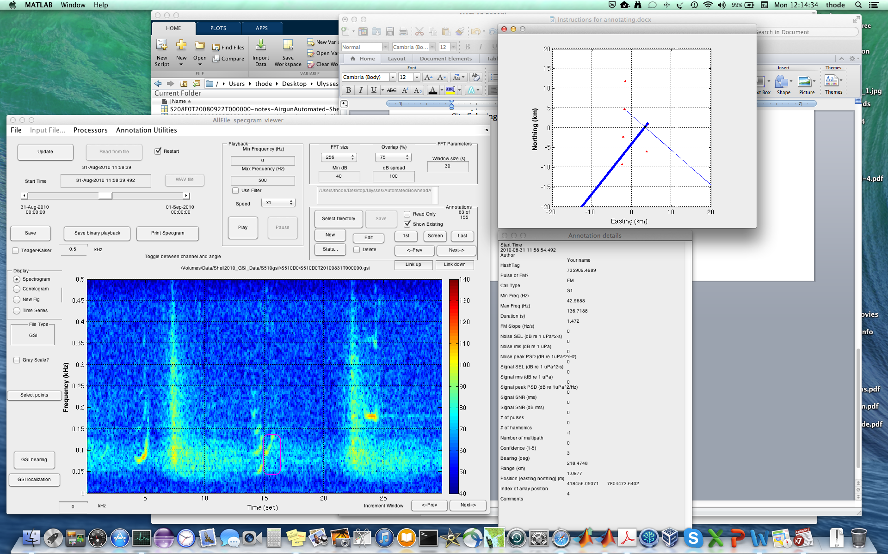

Figure 1: Ulysses display when a linked annotation is selected. Note that besides the annotation detail window, a plot of the location of the call is also included.

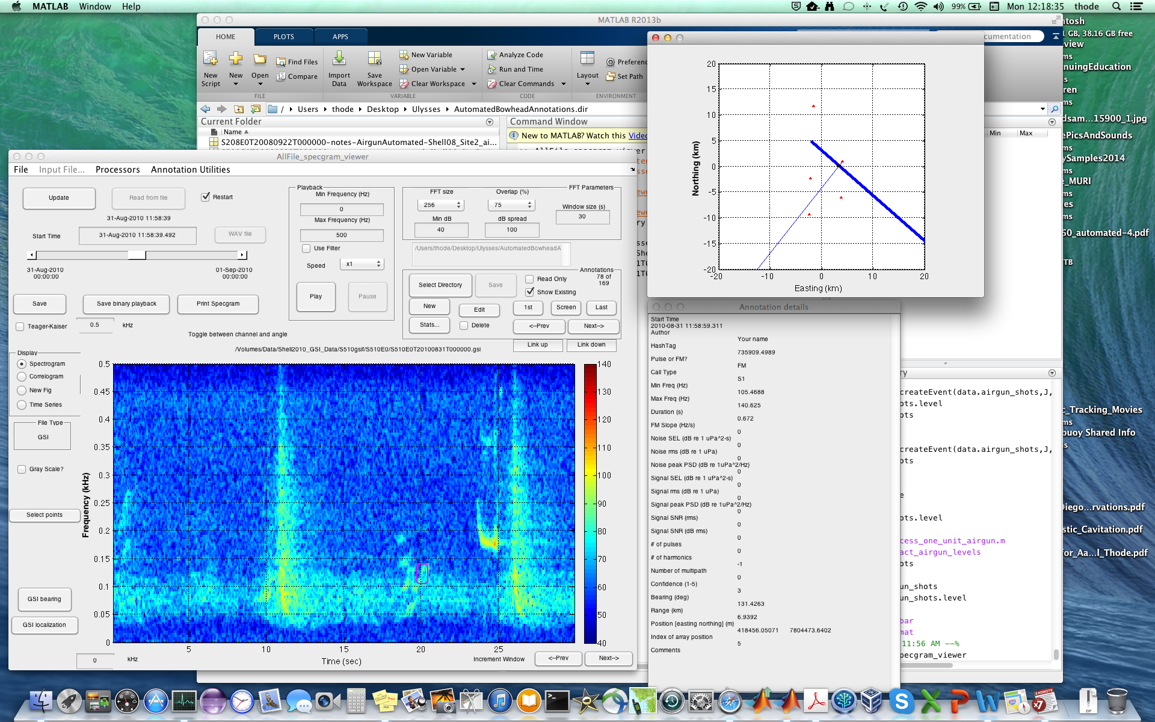

Figure 2: Ulysses display when the “Link up” button is hit.

One can move back and forth between annotations within a single file by selecting “<-Prev” and “Next->”, as with a regular annotation file. However, pressing the “Link up” and “Link down” buttons provides a new direction to move.

By hitting one of these buttons, the program “jumps” to the nearest linked annotation. It does this by saving the current annotation file, loading a new file and new annotation file, and displaying the result. Figure 2 illustrates what the Ulysses display looks like after “Link up” is selected. Note that the position of the call in the map has not changed, only the highlighted bearing changes, reflecting the fact that we are now viewing DASAR E instead of D. Note that the title above the spectrogram tells you the current title. By continuously pressing the “Link up” or “Link down” button one can cycle through all the annotations linked to this particular call.

How does this work? Each annotation has a unique ID called a “hashtag”. Whenever you create a new annotation, a new hashtag can be created, or a hashtag belonging to another annotation can be copied. If two annotations have the same hashtag, then that means they are part of the same call. For example, two harmonics drawn with two separate annotations can be linked with the same hashtag to indicate that they are part of the same call.

A linked annotation not only has its hashtag, but it also contains a list of other annotation files “link_names” and a list of other hashtags that allow it to locate the linked annotation on another file. In general, linked annotation files must be in the same folder.

**Goals of Analysis**

There will be three types of editing that can be performed with linked annotations: (1) Changing the bounding box of an annotation; (2) adding a harmonic to an annotation; (3) fixing an incorrect linkage between annotations, by either (3a) changing the annotation being linked, or (3b) deleting the annotation.

Let’s begin by locating the following annotation in DASAR D (Figures 3 and 4). This annotation is linked to three other DASARs (four linked files total). It can be found in S510D0T20100831T000000-notes-BowheadAutomated-Center.mat

**Changing bounding box**

There are two ways to change the size of the bounding box for a given annotation. The safest is to select the “edit” button when the annotation is highlighted by the pink bounding box, and manually adjust the min freq, max frequency, and duration, and then hit “OK”.

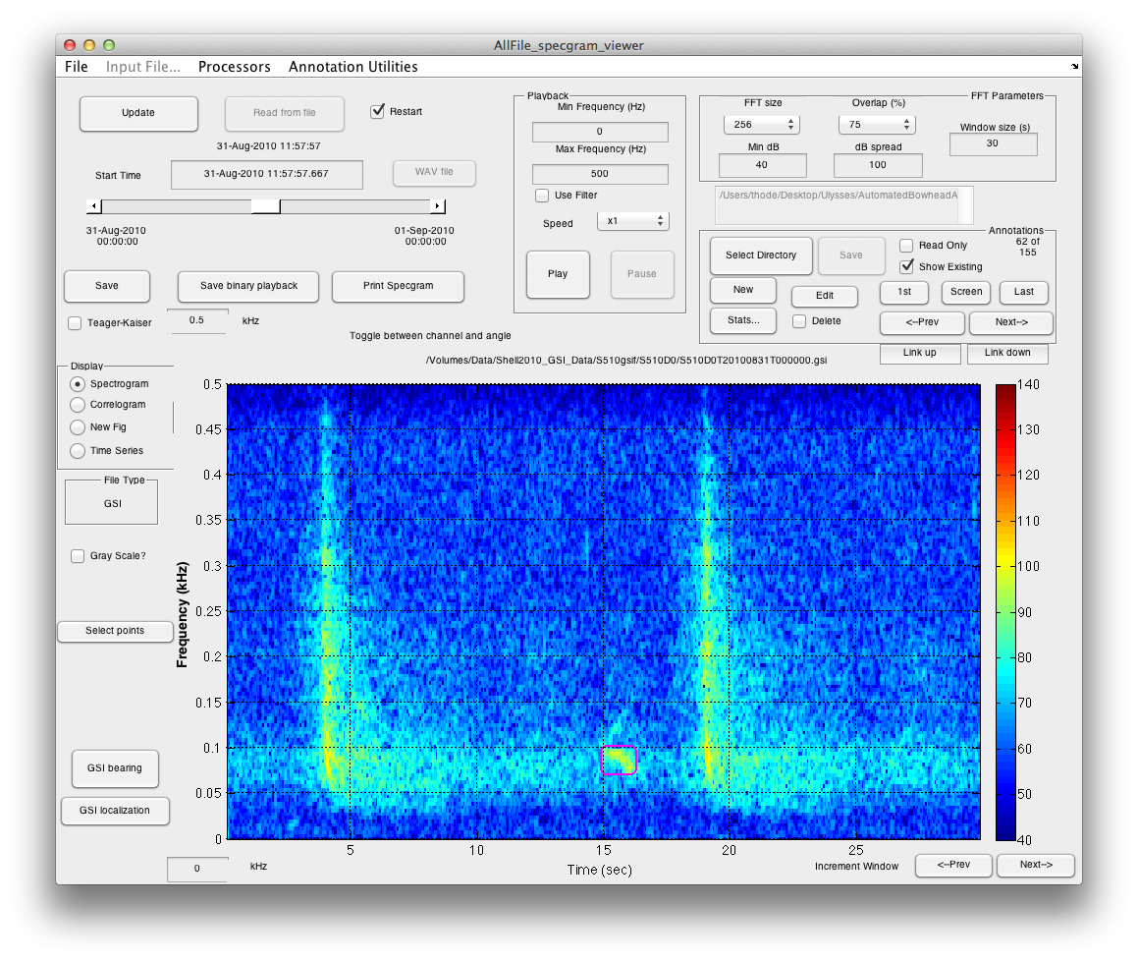

Figure 3: Annotation 62 of 155 in DASAR 5D.

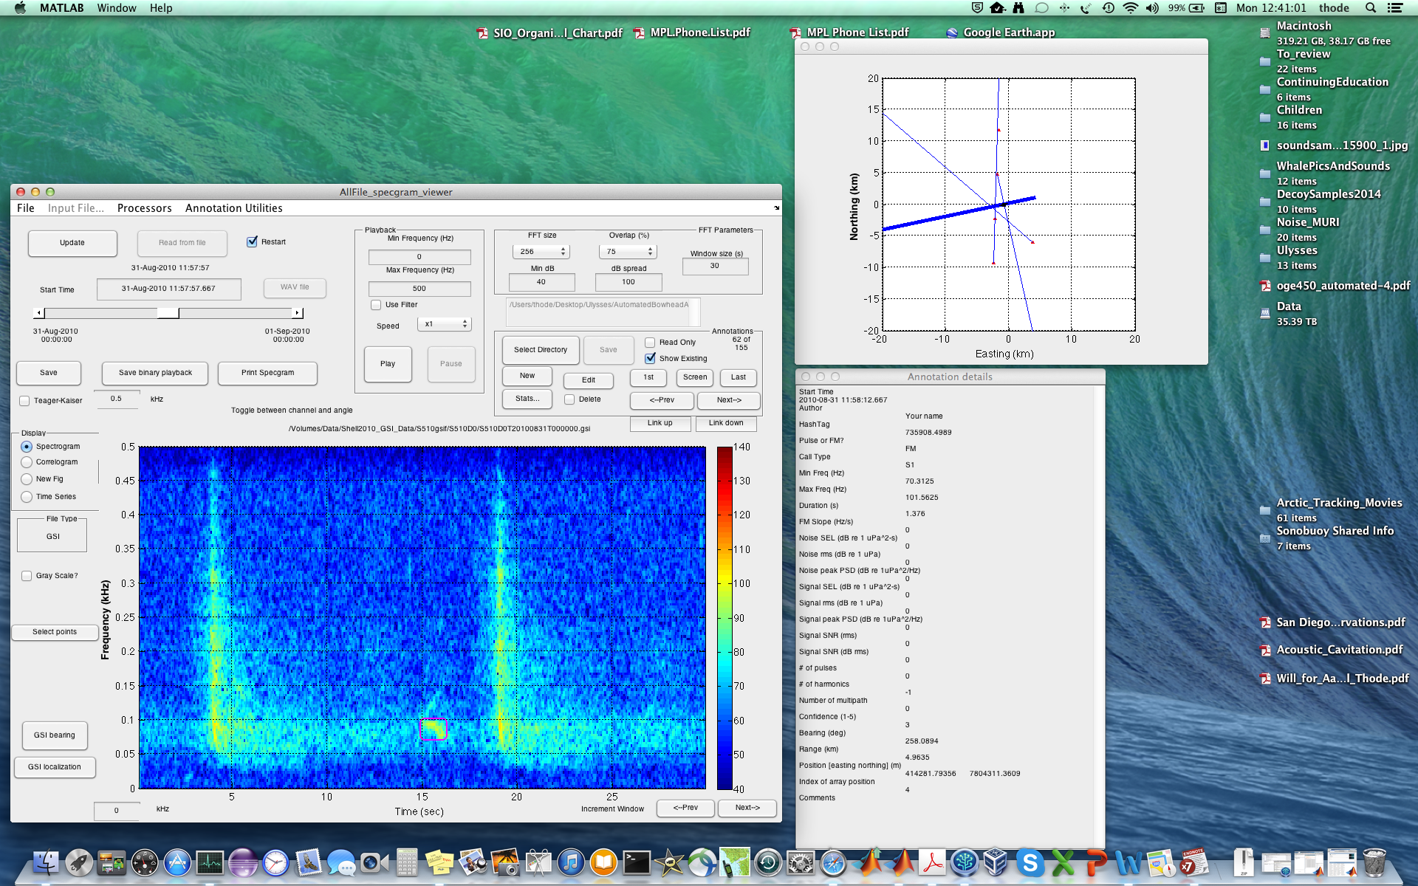

Figure 4: All Ulysses windows for annotation 62 of 155.

Unfortunately, you cannot change the start time of a bounding box this way. So the second way to do this is to create a new annotation, and delete the old. Do these steps:

1. Make sure the annotation box you want to change is highlighted in pink. As a precaution, you can hit the “Next” and then “Prev” buttons to check.
2. Select “New” annotation and click twice to define your new box. It is OK to overlap with the original box!
3. A new window will appear:

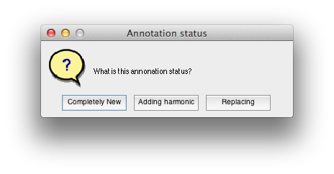

Figure 5: Annotation status window appears when a new annotation selected.

1. Select “Replacing”. This copies the hashtag of the current detection into the new detection, preserving all linkages.
2. The edit window will appear: remember to enter your name as “Author”. Note that you can see the names of the other linked annotation files and other annotation hash tags. Click on “OK” to close the edit window.
3. The new bounding box should now be pink, and the original white. Click “Next” or “Prev” as needed in Annotations to return to the original bounding box. Check that all the thin blue lines on the map view are the same between the old and new annotation (the thick blue line may change slightly).
4. When the old annotation is highlighted, select “delete” checkbox and then press “Delete”.
5. UNCHECK the “Delete” checkbox. If you don’t you will get a warning window whenever you press the “Link up” and “Link down” button.
6. Save the result. You can cycle through the “Link Up” and “Link Down” buttons to make sure that all the links have been preserved.

**Adding/changing harmonics**

To add a harmonic or other related component to a current annotation, do the following steps. Please locate Annotation 69 of 155 in the S510D0T20100831T000000.gsi file (Figure 5) as a walkthrough. Annotation 59 of 156 for the 5D DASAR also gives some good practice…

1. Resize the original bounding box as needed, in order to ensure that the bounding box only covers one call component. Thus follow the steps for “Changing Bounding Box” listed above. In many cases, it will be simplest to just edit the annotation maximum frequency. Save your work.
2. Once you have the revised bounding box (from either a simple edit of the maximum frequency, or the creation and deletion of the entire annotation), open the edit window and enter the number of harmonics you will be adding (including the base harmonic).
3. Make sure the original bounding box is highlighted in pink, then select “New”. Select the harmonic you want.
4. Select “Adding harmonic” in the Annotation Status box. This copies the hashtag of the current selection to the new selection (along with the number of multipath).
5. Save your work and click on the “Prev” and “Next” annotation buttons to switch between the original detection and the harmonic. The map should change very little between the annotations, and the “HastTag” entry in the Annotation details window should not change between the annotations.
6. If harmonics exist on one file, they probably exist on other files, so select “Link Up” or “Link down” and repeat steps a-e for the other linkages. Be sure to save the annotations before hitting the link buttons—they should be automatically saved for you, but it is best to develop good habits early on.
7. Note that when you link up or down the annotations, and two annotations share the same hashtag, then the one that is detected first (earliest bounding box left edge) will be the one selected. So don’t be afraid if you don’t see harmonics highlighted in pink as you link up or down.

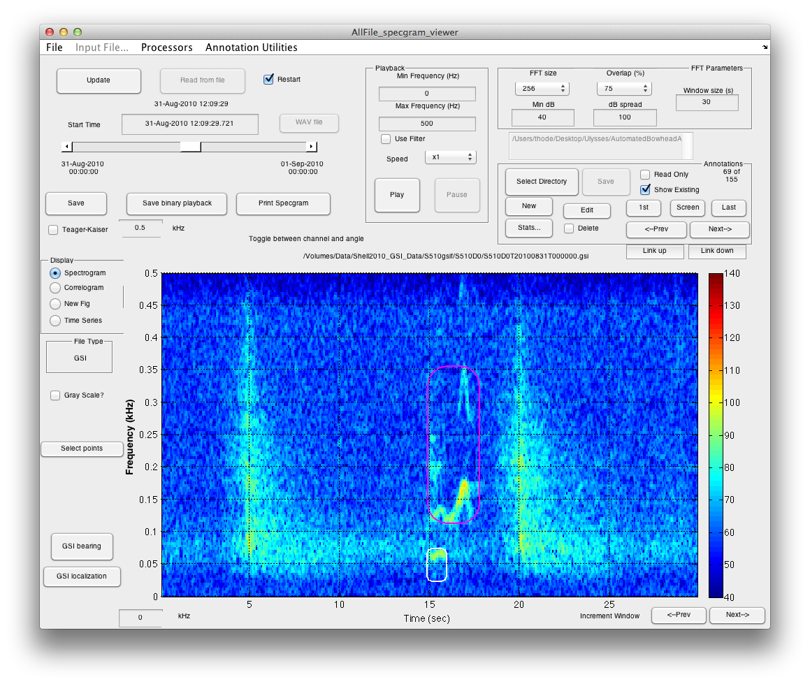

Figure 5: Original annotation 69 of 155 in S510D0T20100831T000000.gsi

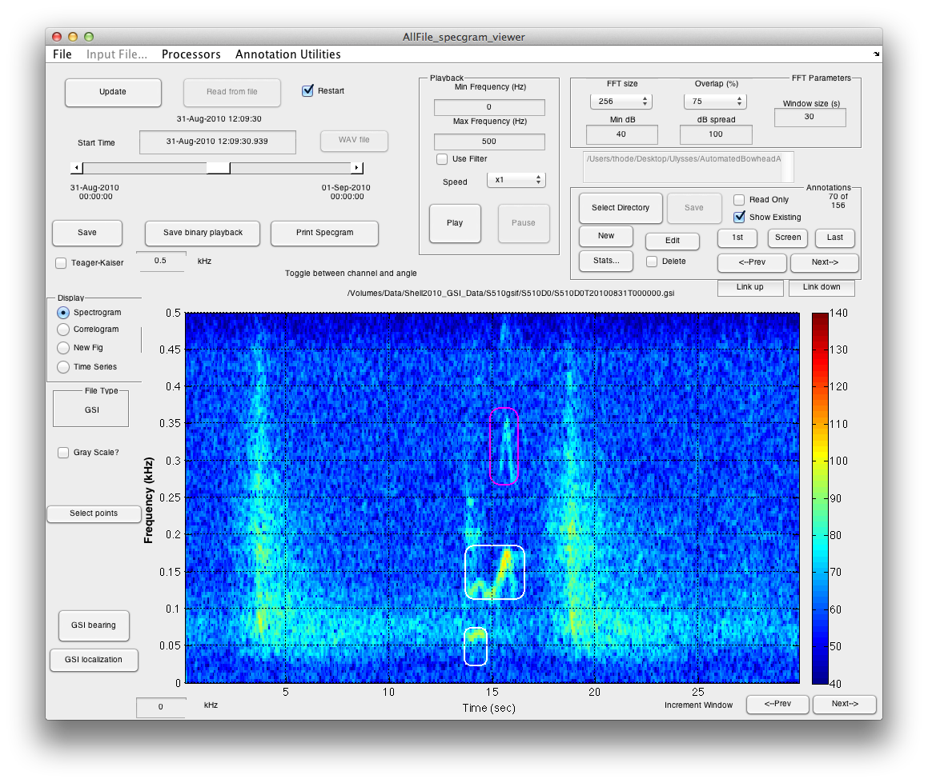

Figure 6: Final annotations for harmonic example.

**Changing a bad link**

Many of these linked annotations are generated by a computer program (**Thode ref), and mistakes due happen. Please locate Annotation 75 of 156 on DASAR 5D:

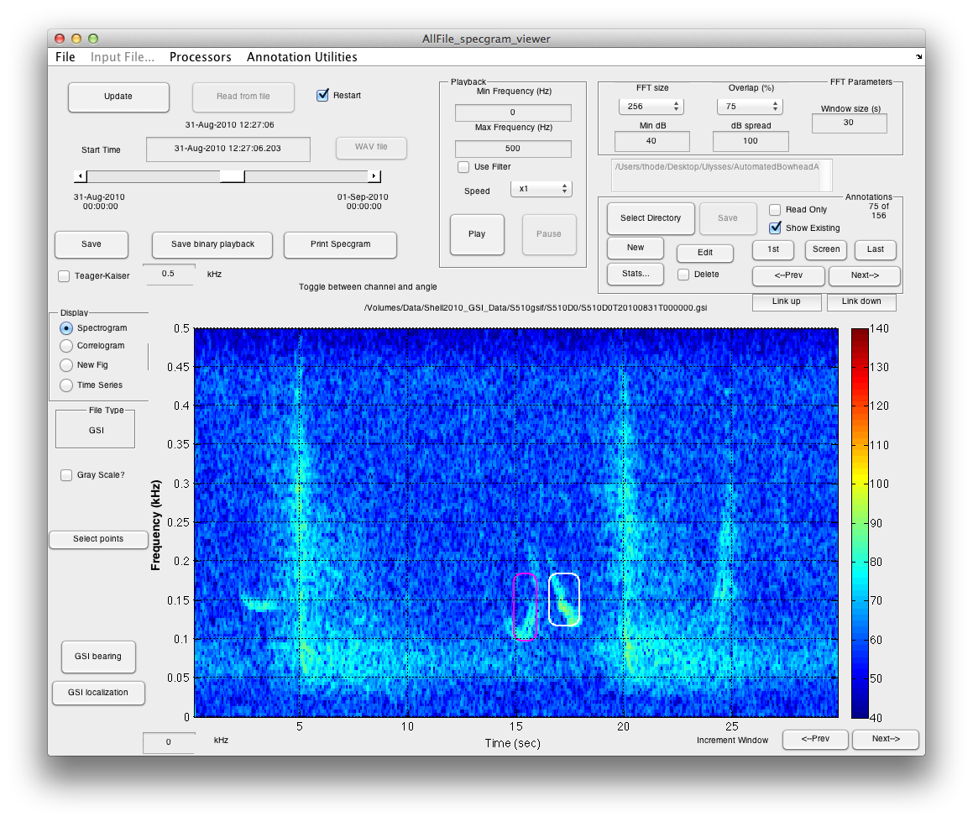

Figure 7: Annotation 75 of 156 on DASAR 5D, illustrating bad link.

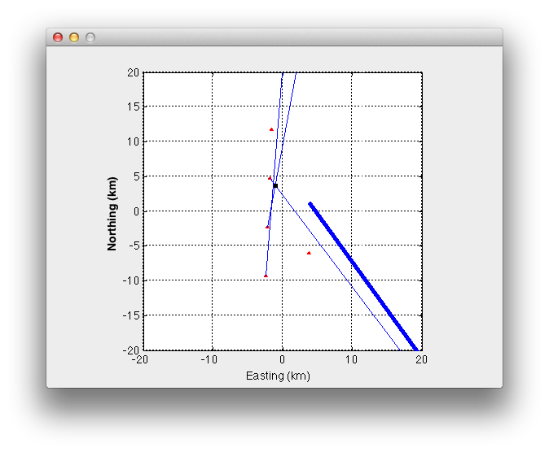

Figure 8: Example of bad links for annotation 75.